https://onthemap.ces.census.gov/

“On the Map” to determine “Who Works Downtown”
- Go to: https://onthemap.ces.census.gov/

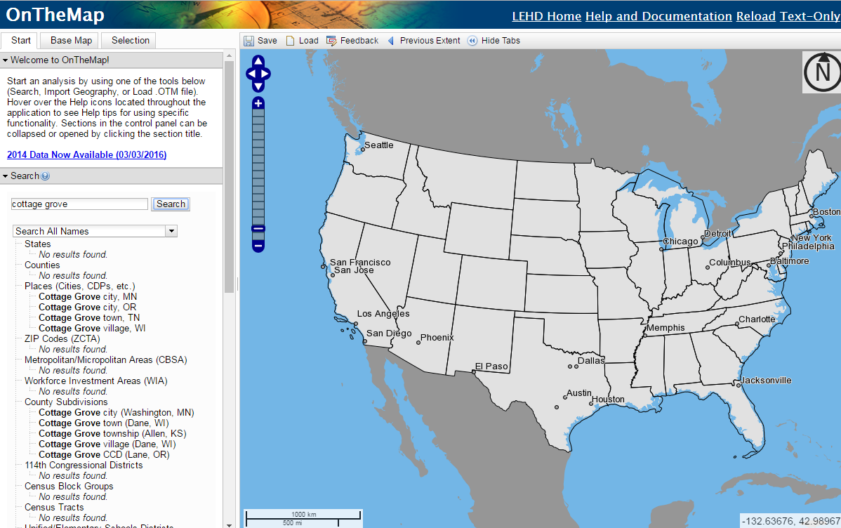

- Using the map, zoom into your community and its downtown.

- Click the “Selection” tab.

- In the sidebar click “draw polygon (freehand)”

- The cursor will be a small circle instead of the normal arrow. Place the circle on the map of where you want one of the vertices of your “downtown polygon” to be. Then continue to click on the map until you have your desired polygon outline. When you are finished double click on the last point to end the freehand mode.

- Click confirm selection at the top of the page.

- This will lead to a “Selection Area" popup box:
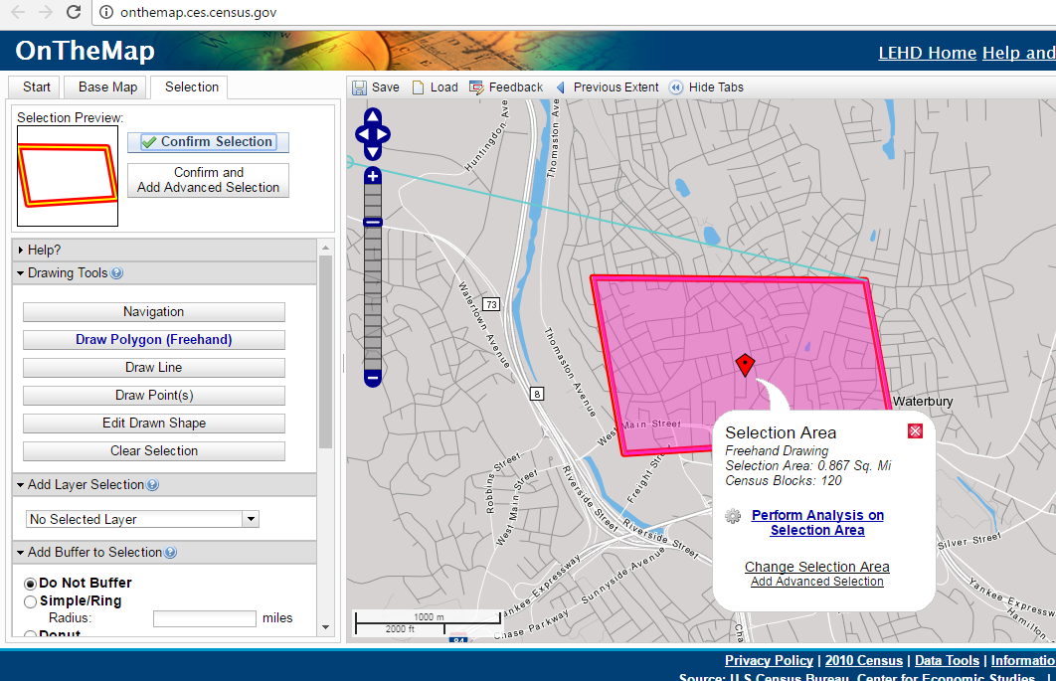
- Click on perform analysis on selection area

- Choose what you are looking for. In this case who works within the polygon

- Click go and see your results.

