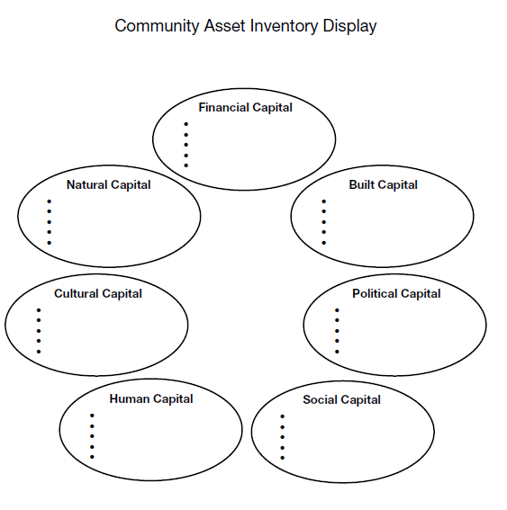
Old Saybrook, CT

Bristol CT

Bangor, ME

Bennington, VT

Springfield, CT

Groton, CT

Gardner, MA

Freeport, ME

New Haven, CT

Granby, CT

