First Impressions Community Announcement Media Template
Wondertown Hopes to Make a Good First Impression
Connecticut Main Street Center and the University of Connecticut Extension have connected Wondertown and Lovelyville as part of the First Impressions Community Exchange Program which provides a fresh set of eyes on community assets and challenges.
The structured assessment is designed to help communities learn about their strengths and shortcomings through the eyes of first-time visitors. Communities are matched with a similar community or neighborhood in terms of size, location, amenities or natural features. Teams of 4-8 volunteers from each community are trained, conduct unannounced visits in the partner community, and then report their findings.
“Communities may already know what their challenges are, but because they hear them every single day, they might not be paying attention to them anymore,” said Susan Westa, CMSC’s Community Engagement Director. “But somebody from the outside with a different perspective offers new insights and ideas.”
The timeline for an exchange is 3-4 months from training to final report. Participants become “secret shoppers” for the day and follow procedures to document their visit using a guidebook and uploading photos and comments. The guidebook ensures that evaluations and reports are thorough and uniform and requires minimal training. Reports from the program are often used as part of broader community assessment or planning processes to inform community policy and action.
"We think this program will provide a great opportunity for Wondertown" to gain insights into XXXX that we hope to use to XXX" said, representative of your community. "We're currently soliciting interest from anyone who would like to join the visit team. Those interested should contact XXX. The visits between Wondertown and Lovelyville are unannounced but will take place sometime between XXX and XXX.
First Impressions is sponsored by UConn Extension in partnership with the Connecticut Main Street Center. It was developed by the University of Wisconsin Cooperative Extension in the 1990s. More information about the program is available at http://s.uconn.edu/3ww.
Communities interested in participating can learn more and download the short application form at http://communities.extension.uconn.edu/firstimpressions/. For more information contact Laura Brown UConn Extension, laura.brown@uconn.edu, 203-207-0063 or Susan Westa, CT Main Street Center, susan@ctmainstreet.org, 860-280-2032.

###

About UConn Extension
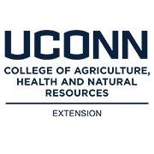
UConn Extension empowers communities by building a network of awareness and knowledge. Extension is a nationwide effort to give the public access to research-based information, scientific expertise, and educational programs they can use to enhance their everyday lives. UConn Extension, a program of the College of Agriculture, Health and Natural Resources (CAHNR) works in all 169 towns of Connecticut with a network of over 100 educators and scientists. Over 2,900 volunteers leverage the ability of Extension to work in every community.

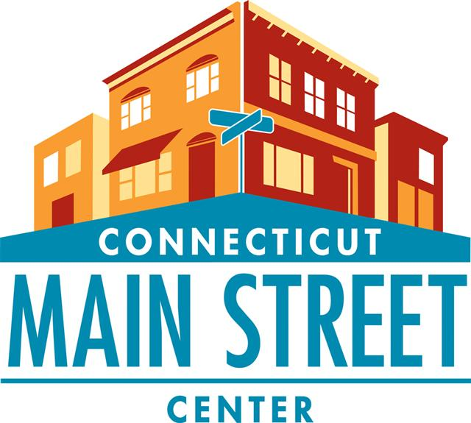
About Connecticut Main Street Center

CMSC’s mission is to be the catalyst that ignites Connecticut’s Main Streets as the cornerstone of thriving communities. CMSC is dedicated to community and economic development within the context of historic preservation, and is committed to bringing Connecticut’s commercial districts back to life socially and economically.
CMSC is supported by its Founding Sponsors, the CT Department of Economic & Community Development (DECD) and Eversource Energy. CMSC is also supported by its Growth Sponsors, UIL Holdings Corp. and the State Historic Preservation Office. More information is available at www.ctmainstreet.org.

